**Speed of Light**

[Physics 3600 - Advanced Physics Lab - Summer 2021](http://northeastern.edu/heiman/3600/index.html)

Don Heiman, Northeastern University, 6/8/2021

This experiment introduces you to high-speed laser diodes and detectors, which are key elements in optical communications. Short light pulses of a few nanosecond duration (few feet long) are sent through various media (air, glass, water,) in order to determine the velocity of light (*v*) and index of refraction (*n*=*c*/*v*) in each medium. The velocity of light in a vacuum (~air) is *c*.

A goal of the lab is to make **precise** measurements.

**I. INTRODUCTION**

Fiberoptic (FO) systems are routinely used for long distance telephone and internet communications and they are presently being implemented for shorter distances. The FO communication system illustrated below contains: (*i*) a laser diode (LD) which is electrically modulated (on/off) with the digital input information; (*ii*) a FO cable for transmitting the light pulses; and (*iii*) a photodiode to convert the light pulses back into electrical pulses.

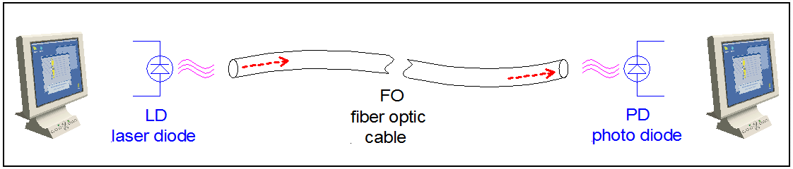

Most long-haul FO systems use light pulses generated by a GaInAsP semiconductor laser diode operating at 1.55 μm wavelength where the optical absorption in the glass FO is minimum. In a 10 GHz system the pulses are only a few cm in length. These pulses are transmitted through single-mode fibers of optical glass (SiO2=silica=quartz) having a core diameter of about 6-8 mm. At the receiving end of the optical fiber the pulses are detected by a high-speed Si or InGaAs photodiode that converts the encoded light pulsed back into electrical pulses.

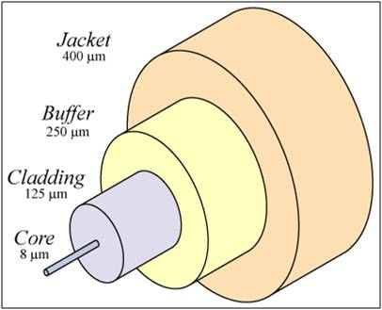The illustrations below show: (left) construction of a FO cable where the light passes through the glass core region; (center) total internal reflection inside the glass fiber; and (right) transmission of light inside the curved FO core. Light is confined inside the core by total internal reflection for angles greater than about 70 degrees from the normal. For light to exhibit total internal reflection, the cladding layer must have a smaller refractive index (*n* = *c*/*v*) than the core region.

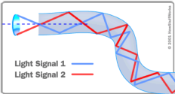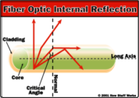

**II. APPARATUS** (be sure to write down manufacturer and model numbers in your report)

optical breadboard, beamsplitter, 2 mirrors (M1, M2), lens (100 mm focal length)

focused standard laser diode, high-speed nanosecond pulser (see below)

2 amplified, high-speed silicon photodiodes (PD1, PD2)

high-speed (500 MHz) oscilloscope, EasyPlot

water-filled optical cell

optical fiber (SiO2 quartz glass) with large core, FO mounts

**III. PROCEDURE**

***This experiment challenges you obtain the highest accuracy possible.***

***A. Test Pulse, Scope and Laser Diode***

Confirm that the pulser is turned **OFF**.

Connect the output of the pulser to the scope input Chnl-1.

Turn pulser **ON**.

Trigger the scope on Chnl-1.

Adjust the trigger level to ~2 V, so that you see several **square** pulses on the screen.

Stop the scope triggering to capture a few pulses.

You need to plot only 2-4 pulses in order to see the period of the pulses.

Transfer the waveform from the scope to the computer.

a. Describe what you see. What is the frequency of the pulses and the approximate amplitude?

Turn **OFF** pulser.

Connect pulser output to the laser diode (LD).

Turn **ON** pulser.

Look for red light from the LD.

***B. Nanosecond Pulse Generator for Laser Diode***

The [Fast-Edge Pulse Generator](https://www.youtube.com/watch?v=9cP6w2odGUc) uses six 74AC14 Schmitt Triggers arranged in the circuit shown on the right, and mounted on a home-made copper [circuit board](https://www.eevblog.com/forum/projects/super-simple-'fast-edge'-pulse-generator-for-scope-based-basic-tdr/?action=dlattach;attach=79836) shown on the left.



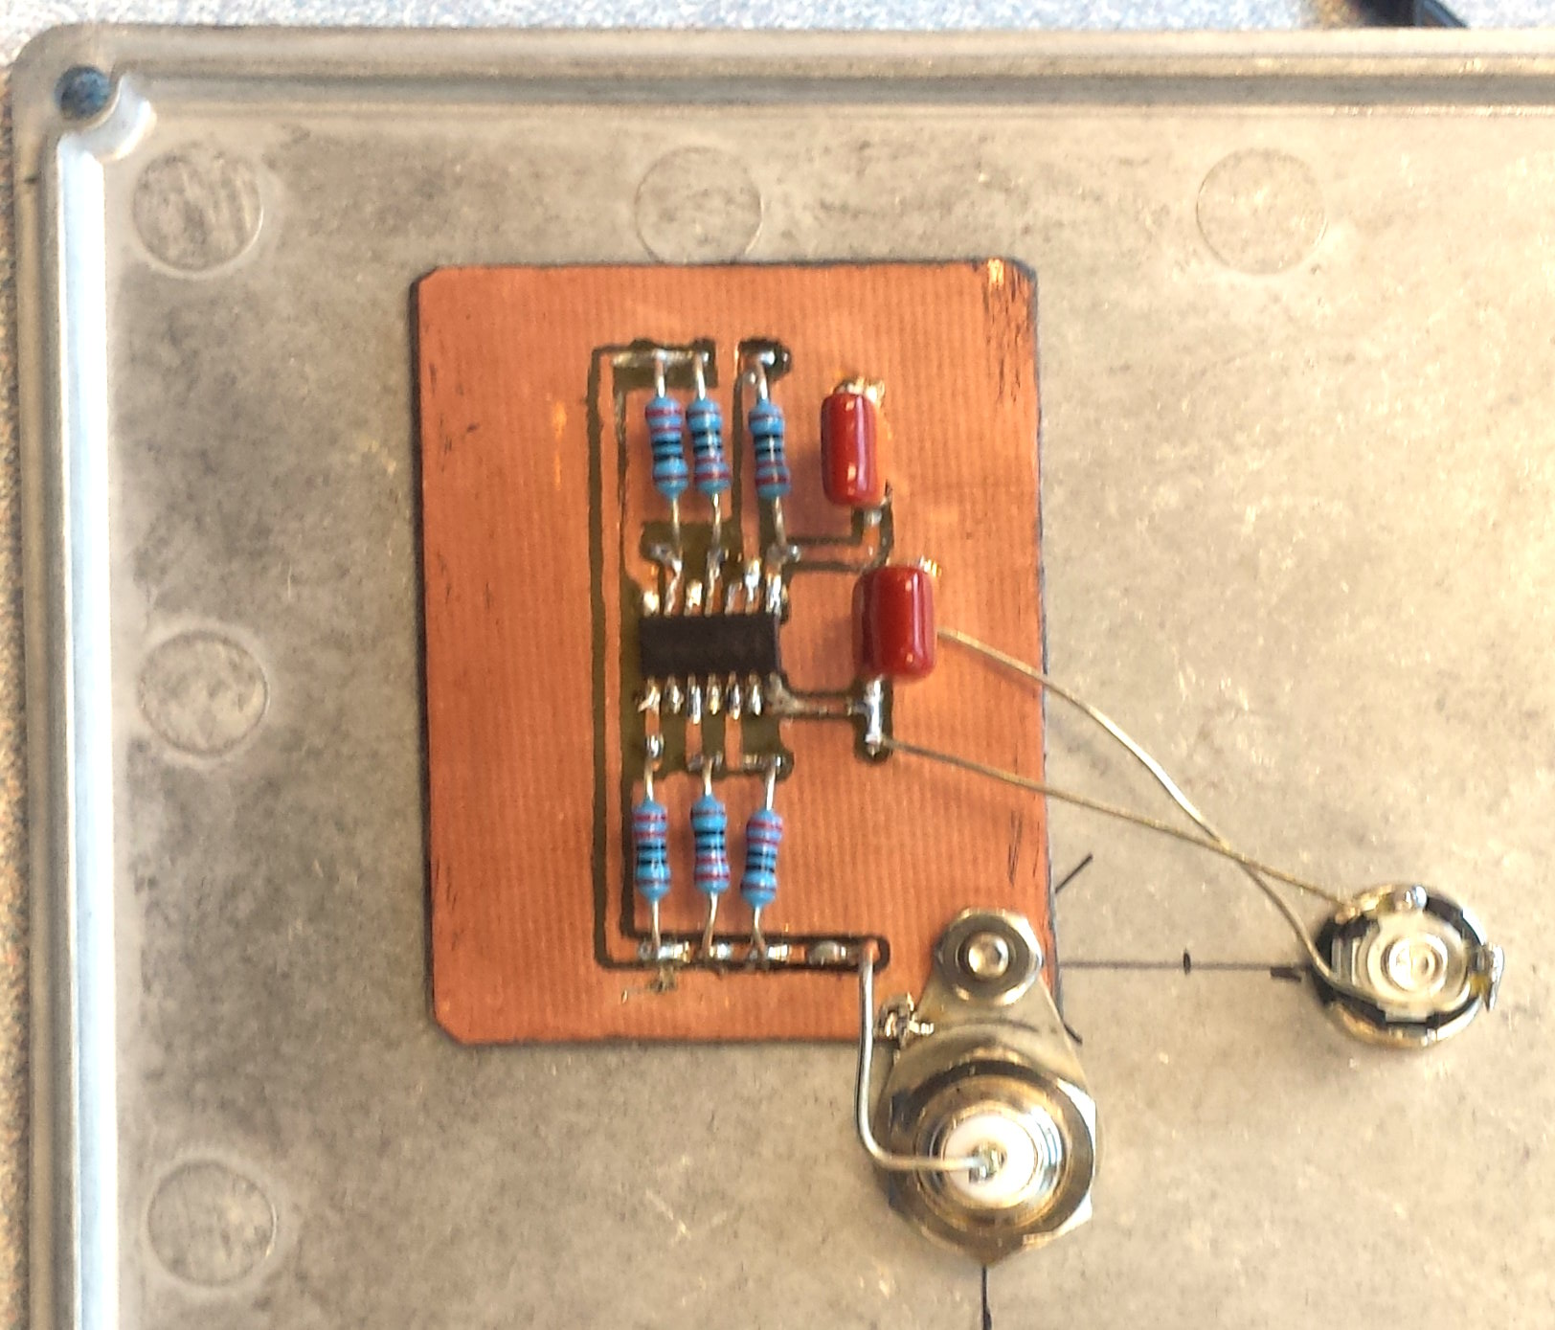

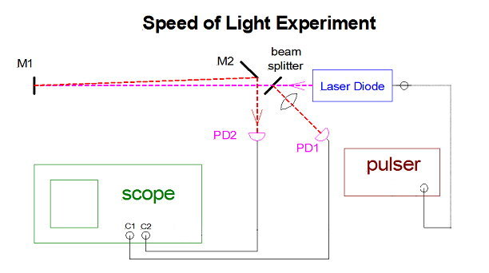

***C. Initial Optics Setup***

Configure the optical components roughly as shown in the diagram.

Place the small focusing lens between the beam splitter and PD1 to reduce the spot size.

Adjust both beams to hit the centers of the photodiodes.

Connect the photodiode (PD1) to the scope Chnl-1 input.

Connect the photodiode (PD2) to the scope Chnl-2 input.

Trigger the scope on Chnl-1.

Look for the **nanosecond** photodiode peaks on scope Chnl-1 and Chnl-2 (>20 mV).

Finely adjust the beam splitter and the mirror M2 to maximize the PD voltages.

a. What is the “10-90” rise time of the leading edge of the nanosecond pulse (10% to 90% intensity).

b. What is the approximate width (FWHM) of the peak of the nanosecond pulse.

Temporarily add another length of coax cable to **PD2**.

c. Copy the photodiode pulses, with and without the extra cable, onto a single plot.

d. Measure the added delay time precisely and compute the “effective” index (*n*=*c*/*v*) of the cable.

**You must show the TA your results and plots at the end of each section before proceeding to the next section.**

***D. Speed of Light and Index of Refraction***

**For your time-shifted plots, always overlap the two photodiode pulses in a single plot.**

**The plots should focus closely in on the time shift in the peaks. For example, use an x-axis range to make the time shift roughly 20% of the x-axis range.**

**1. Air**

Return to equal length cables.

a. Measure the time lag between the two PD pulses on the scope.

Find the time difference precisely to an uncertainly much less a nanosecond.

b. Measure the path difference precisely of the two beams.

c. Compute the speed of light in **air**, including the uncertainty.

d. How would unequal cable lengths affect your results?

**2. Glass**

Next, measure the refractive index of glass.

Capture the pulse from PD2 on Chnl-2.

Remove PD2 and carefully replace it with one end of the FO cable in a holder.

Screw the other end of the FO into PD2.

a. Record the time shift produced by the added FO cable.

Measure the time difference precisely.

b. Compute the refractive index (*n* = *c*/*v*) in **glass**, including the uncertainty.

**3. Water**

Measure the refractive index of water.

Configure the path of the laser so that the returning beam, which is reflected from the mirror M1, hits the second mirror M2 about 5 mm from the original laser beam path (see diagram).

Place the tube containing water in the beam in a double-pass configuration. Note that the water cell may deviate the beam slightly, so make sure the beam travels through the center of the cell.

a. Compute the refractive index *n* in **water**, including the uncertainty.

(Note that the time lag in the water *replaces* the time lag in the air.)

b. Measure the wavelength of the laser with the Amadeus spectrometer and Quantum software.

**IV. SUMMARY**

a. In a TABLE, compare the measured values (with uncertainties) of

*c*, *n*glass, and *n*water to accepted values.

Look up accepted values and cite the references.

b. Discuss in **detail** how you precisely measured the time shifts of the peaks

c. Discuss how refractive indices generally vary with wavelength, *n*(λ).

d. What are the two primary ways to improve the accuracy of the results?