**Spectroscopy of Ruby Fluorescence**

[Physics 3600 - Advanced Physics Lab - Summer 2021](http://northeastern.edu/heiman/3600/index.html)

Don Heiman, Northeastern University, 6/8/2021

**I. INTRODUCTION**

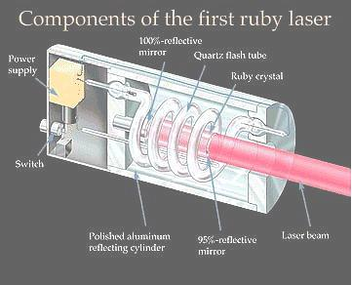The laser was invented in May 1960 by Theodor Maiman while working at the Hughes Research Lab in Malibu, California. This first laser was constructed of a cylindrical ruby crystal surrounded by a photographic flash lamp, all contained in a polished aluminum cylinder (shown on the left). The flash lamp was used to excite the chromium ions in the sapphire host crystal. As the excited Cr(3+) ions de-excite they emit light as individual photons. Then as these photons travel back and forth in the optical cavity between the mirror-coated ends of the crystal, they induce other excited Cr ions to de-excite causing "stimulated emission." Rapidly, all of the ions become de-excited and generate a lasing light pulse. The light beam is *coherent* in the sense that the photons all travel in the same direction and have the same electromagnetic *phase*. LASER is an acronym for Light Amplification by Stimulated Emission of Radiation.

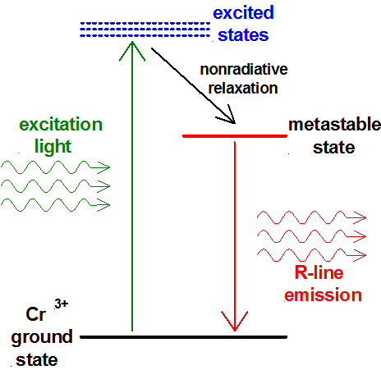

This type of laser requires three energy levels, as shown in the diagram on the right. Absorbed pump light excites the Cr3+ ion into excited states. The lifetime of these levels is short (50 ns), so that the excited ion quickly relaxes by making a transition to the long-lived metastable state. The energy which is lost in this process is nonradiative and goes into heating the crystal by generating *phonons* that are vibrational excitations of the crystal atoms. The metastable energy level must have a lifetime which is long enough to enable the Cr ions to remain excited until a photon having the precise energy comes along to de-excite it. The lasing line in ruby is the so-called "R-line" having a wavelength of ~0.7 μm. The fluorescence lifetime of the R-line is several ms. Fluorescence of the R-line can be excited by light in any of three absorption bands, at 250, 410, and 550 nm.

This lab experiment does not produce lasing in ruby, but it investigates the excited states via the absorption spectrum and spontaneous fluorescence. A green laser is used here for exciting the R-line fluorescence.

**– CAUTION –**

**Never look directly into any laser beam.**

**Also, make sure there are no reflections that exit the bench top.**

**Place unnecessary optical components to block stray beams from exiting the bench top.**

This green laser has a power of approximately 5 mW. Compare this to the 1 mW of sunlight that would enter your 1 mm diameter pupil if you looked directly at the sun.

This experiment also introduces the widely used tool – the spectrometer – for optical spectroscopy. A spectrometer is an instrument used for measuring the intensity of light as a function of wavelength. Spectrometers usually contain a diffraction grating (or prism) to disperse the light, thereby spreading out the light of differing wavelengths into different positions. The spectrometer unit used here has an internal CCD (charged coupled device) silicon detector, essentially a digital camera detector, to measure the light intensity at various positions along its length. In the figure, light from an optical fiber enters at position #1; reflects off the collimating mirror #4; is diffracted by the grating #5; reflects from focusing mirror #6; then finally is read out by the CCD detector #9. For more information on Ocean Optics spectrometers see their website, <https://www.oceaninsight.com/>.



**II. APPARATUS**

aluminum breadboard with 1/4-20 tapped holes

green laser diode, ~5 mW @ 532 nm

USB2000-FLG or USB4000FL Ocean Optics spectrometer, OceanView software, USB cable

lens, 25 mm focal length, 25 mm diameter, for collecting and focusing fluorescence

lens, 200 mm focal length, 12.5 mm diameter, for focusing the laser beam

mirror, in x-y adjustable mount

photodiode (PD) detector

neutral-density (ND) optical filter (black)

long-pass optical filter (red-orange)

optical fibers, 50 and 600 micron core

white light illuminator

ruby crystal, Al2O3:Cr, approximately 0.05% Cr, length *L*=2.00±0.05 mm

EasyPlot software

**III. PROCEDURE**

***A. Room Light Spectrum***

1. Start the OceanView software. Note the following: adjust Integration Time to keep the peaks below saturation; check the Electric Dark box to remove the background; if the data looks noise then increase the Scans to Average; use Copy to Clipboard then save the clipboard.

2. Insert one end of the 50 μm core fiber optic (FO) into the spectrometer input. Adjust the collection (integration) time so that the highest spectral peak is near but not above saturation. Store data in tab-delimited format after you click on the storage disk icon.

a. Calibrate the spectrometer – use the green laser to determine the shift in the wavelength.

b. If the shift is >1 nm from the expected value, correct the wavelength of all subsequent spectra.

3. Now, point the open end of the FO at the wall or ceiling to collect stray room light. You should see many spectral peaks from the fluorescent room lights.

a. Store the spectrum and include in report.

b. What is the characteristic *linewidth* (full-width at half-maximum) of the narrowest spectral line?

c. List in table form the wavelengths and intensities of the 5 or 6 strongest lines in counts/sec.

d. Why are there separate spectral peaks?

e. What are the colors of the strongest peaks.

***B. Absorption Spectrum***

The light intensity after passing through a material of length *L* is given by *I* = *I*o (1-*R*)2 exp(-α*L*), where *I*o is the initial light intensity (see Appendix). The factor (1-R)2 corrects for reflection losses from the two surfaces, where R = (*n*-1)2/(*n*+1)2 is the reflectivity.

Here, the absorption spectrum α(λ) of the ruby crystal will be measured. Make a new setup where a white light illuminates one end of the 600 μm core optical fiber, but leave a space large enough (10-20 cm) to slide in the ruby crystal just in front of the FO. Cover apparatus with black cloth to shield the room light. As before, adjust the collection time and the lamp/FO such that the spectrometer intensity is just below saturation.

1. Collect and store spectra *I*o (λ) without the ruby crystal, then collect *I* (λ) with the ruby crystal directly in front of the input end of the FO.

2. Roughly compute the transmission T=*I* / *I*o at a wavelength of λ~700 nm.

Retake the measurements until T is in the range 80 % to 90 %.

a. Assuming that α=0 at λ~700 nm and the accepted value for n, what is the expected T at λ~700 nm. Discuss.

b. Plot *I*(λ) and *I*o(λ) on the same graph (after you subtract a constant background from each).

c. Compute and plot the transmission spectrum, T(λ) = *I*(λ) / *I*o(λ).

d. Plot the spectrum of the absorption coefficient as a function of wavelength, α(λ).

e. For the absorption maxima, what is the “absorption length,” 1/α, and uncertainty.

f. Smooth out the noise and discuss the absorption peaks.

g. What is wavelength and width of the main absorption peak?

**You must show the TA your plots at the end of each section before proceeding to the next section.**

***C. Optical Fluorescence Setup***

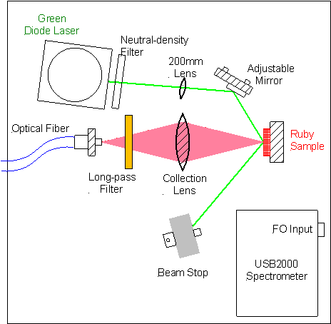Mount the optical components on the breadboard approximately as shown in the diagram and photograph. Before aligning the beam, you must place the black neutral-density (ND) optical filter in front of the laser to reduce the beam intensity.

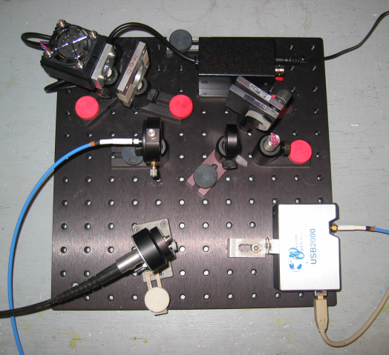

***D. Ruby Fluorescence Spectrum***

Collect laser-excited fluorescence from the ruby crystal and plot its spectrum.

*Optical Setup* – **Before beginning, slide the black neutral-density (ND) filter in front of the laser to reduce the beam intensity.** First, set all of the optical components to equal heights above the plate. Now the collection optics must be finely aligned. Insert one end of the 600 μm FO into the mount that points at the collection lens, and shine a white light source into the other end. Using the *“thin lens formula*,” compute the image and object distances for the *f*=25 mm focal length collection lens. While holding a white piece of paper at the front face of the ruby crystal, adjust the position of the lens and FO so that the white spot image is focused at the front face of the ruby crystal. Now adjust the mirror to overlap the green laser beam and the white spot image on the ruby crystal.

*Measurement* – Insert one end of the FO into the holder pointing at the collection lens and the other end into the spectrometer. Look for the R-line fluorescence in the spectrum. Maximize the intensity of the R-line emission by turning the adjusting screws on the mirror mount. Cover the breadboard with the black cloth.

a. Store the spectrum and include in the report.

b. Record the wavelength of the R-line. Discuss.

***E. Fluorescence Lifetime of Ruby R-line***

This section describes measurement of the lifetime of the ruby R-line fluorescence.

1. *Laser setup* – Insert the 200 mm focusing lens in the laser beam, in order to produce a smaller laser spot on the ruby crystal. Turn the diode laser power switch **OFF** (down). Connect a BNC cable from the TTL output of the function generator to the diode laser power supply. Connect another BNC cable from the “Output” of the function generator to channel-1 of the oscilloscope. Adjust the function generator to output a square wave having a period of 30 to 50 ms (select the 10 Hz pushbutton). Trigger the scope on the edge of the square wave.

2. *Collection setup* – Use the FO to collect the fluorescence from the collection lens, and attach the other end of the FO to the photodiode (PD). Connect the BNC output of the PD to channel-2 of the scope. Turn the PD switch on (up). Next, remove the ND filter from the laser beam. Place the long-pass (red-orange) filter between the collection lens and the FO. This blocks (absorbs) the green laser light, while transmitting the red R-line. On the oscilloscope you should see a signal from the PD which is synchronous with the function generator.

a. Capture one complete period of the PD output and the function generator for your report.

b. Curve fit the decay of the PD signal to an exponential function.

In the region of interest, plot the data as points and the curve fit as a solid line.

c. What is the exponential decay time of the fluorescence? What is the uncertainty?

**IV. SUMMARY**

a. Discuss how you used the “thin lens formula” to optimize the collection of the fluorescence.

b. Compute the photon energies (E) of the green laser line, the absorption peak, and the R-line.

[E(eV)=1239.513/λ(nm)].

c. Make a TABLE listing the important values (with uncertainties) and reference the expected values. Always discuss the origin of the uncertainties.

**V. OPTIONAL**

Measure the index of refraction of the ruby crystal using a reflection from the surface.

**V. APPENDIX**

***A. Thin Lens Formula***

The “thin lens formula” is used here to determine the parameters for focusing the image of the ruby fluorescence into the optical fiber.

Convex focusing lens are useful for projecting an image of an object from one side of a lens onto the other side. See the diagrams. The distance of an image from the lens is related to the distance of the object from the lens by the *thin lens formula*,

1/*i* + 1/*o* = 1/*f*,

where *i* is the image distance, *o* the object distance, and *f* the focal length of the lens. The magnification of the lens is *M*=*i*/*o*. A special case of this formula is the focusing of a collimated laser beam. There the object distance is infinite, so the laser beam is focused to a small diameter spot at a distance *i*=*f* from the lens, shown in the lower diagram.

***B. Light Absorption***

Materials which absorb light, such as the ruby crystal used here, have an absorption coefficient α which characterizes the depth to which light penetrates into the crystal. The light power *P* (or intensity *I* ) decreases as a function of increasing distance *x* into the material given by

*P*(*x*) = *P*o *exp*(-α*x*),

where *P*o is the initial power at *x*=0. The **absorption length**, 1/α, characterizes the penetration depth of the light. Light energy absorbed in the ruby crystal is converted into energy stored in the excited Cr ions (plus some energy lost which goes into heating the crystal). Note that light ***intensity*** is the light *power* divided by the cross sectional area of the light beam, *I* = *P* / *A*.

***C. Optical Excitation***

Each photon of green light absorbed by the ruby crystal raises the energy of a Cr ion to an excited state. This state rapidly relaxes to the long-lived metastable state having a lifetime *t*. Before the light is turned on, all the Cr ions are in the ground state. After turning on an excitation source, the number of excited ions increases. After time *t* of weak excitation, the number of excited ions is given by

*N* (*t*) = *N*o [1- *exp*(- *t* / τ)],

where *N*o is the number of ions which are excited after the crystal has been weakly illuminated for a long time *t* >> τ. Neglecting stimulated emission, the excitation process comes to equilibrium when the rate of excitation equals the rate of decay from the metastable state. The rate at which Cr ions are excited is *P* / *h*ν, where *h*ν = *hc*/λ is the photon energy. The rate of decay is 1/τ. At equilibrium, the number of excited Cr ions *per unit volume* is given by *n*o = α I τ/*h*ν. After the exciting light is removed, the number of excited Cr ions decreases exponentially for increasing time as

*N* (*t*) = *N*o *exp* (- *t*/τ).

***D. Chromaticity Diagram***

All the possible colors of light which the human eye can distinguish can be made by adding relative amounts of the three additive ***primary*** colors: red, green and blue. These are related to the three wavelength-dependent photoreceptors in the human eye. The relative response of the three photoreceptors is shown below. Note that the spectrum for each color is fairly broad, covering 100 to 200 nm, compared to the total 300 nm width of the visible spectrum 400-700 nm. These three colors are also used in TV and computer color monitors.



Left: Spectra of the three colors.

Below: CIE 1931 Color

Matching Functions.

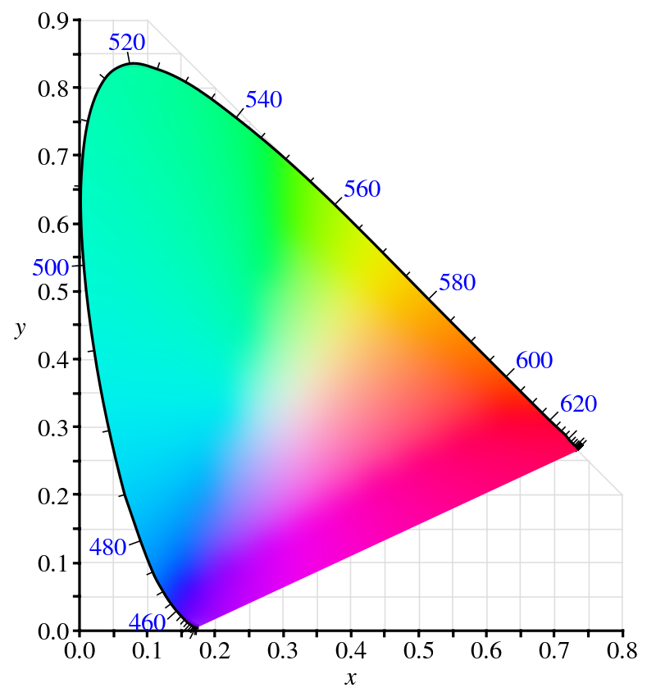In the mid-19th century, J.C. Maxwell first described a diagram, the Maxwell triangle, to quantitatively represent all possible colors using the three primary colors. The Maxwell triangle has been updated into the universally accepted CIE chromaticity diagram, shown on the right. In this diagram, the x- and y-axis are the relative amounts of red and green light, respectively, and the amount of blue is 1-x-y. The outer rim of the “tongue” shape represents pure or saturated colors (*hues*), and is light of a single wavelength. Going inward from the edge towards the center is equivalent to adding white light, referred to as changing the *tint*. Pure white light is composed of an equal mixture of the three primary colors, x=y=z=0.33. Note that the light from the green laser used in the experiment (532 nm) lies on the upper, outer edge at x=0.17 and y=0.79. It is interesting that after dark you can see many variations of “white” lights that are distinguishable.

<https://en.wikipedia.org/wiki/CIE_1931_color_space>